Use-Case Realization Report
Take Exercise

Issue <2.0>
Revision History
Date | Issue | Description | Author
01/08/09 | 1.0 | Initial Version | Haiyang
16/09/09 | 2.0 | Revised after peer review | Haiyang

Table of Contents
1. Brief Description 4
2. Flow of Events 4
3. Interaction Diagrams 5
3.1 Collaboration Diagram for Take Excercise 5
4. Participating Objects 5
5. Class Diagrams 6
5.1 Class Diagram for Take Excercise 6
6. Derived Requirements 6

Use-Case Realization Report
Take Exercise

Brief Description

Flow of Events

Standard Flow
- User clicks the link to start doing exercise.
- Exam Controller will pick questions from question pool and generate the exercise questions.
- Questions will be displayed on Exam Page.
- User can navigate through the questions by clicking “Prev” and “Next” button.
- User can view the right answer by clicking “Show Answer” button.
- After exercise, user can click the “submit” button to finish the exercise.
- the summary of the result will be displayed on Exam Page.

Exception Flow
If user logs off from the system without finishing the exercise, his/her session will be cleaned.

Interaction Diagrams

Collaboration Diagram for Take Excercise
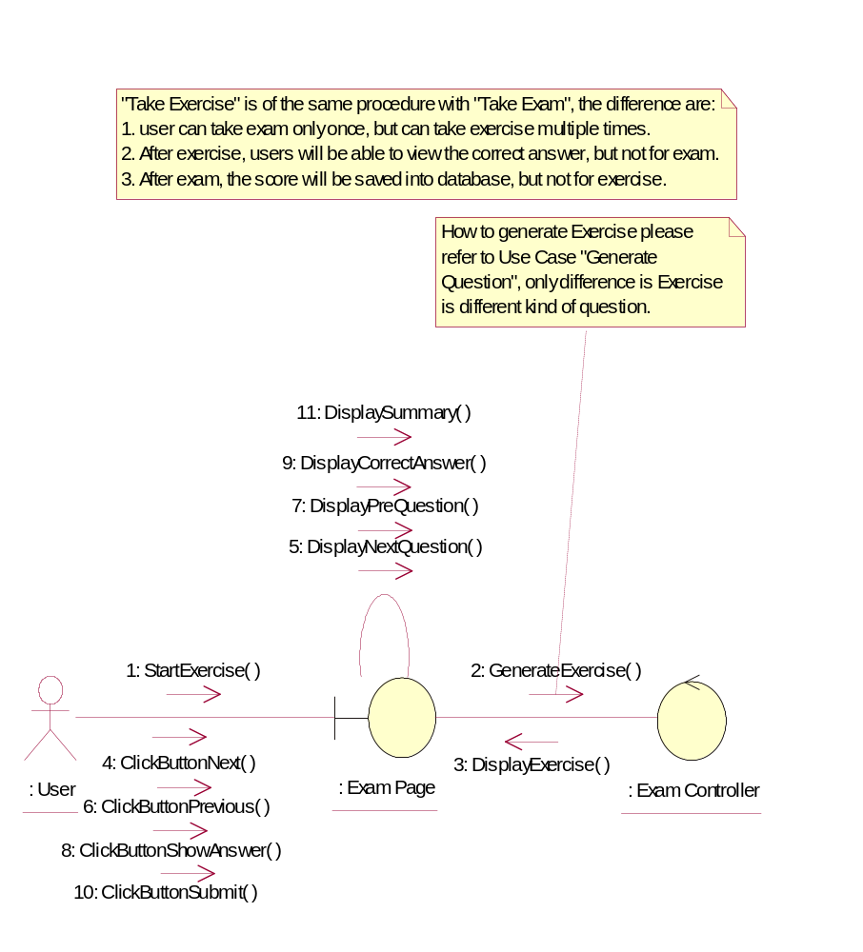

Participating Objects
: Exam Controller

: Exam Page

: User

Class Diagrams

Class Diagram for Take Excercise
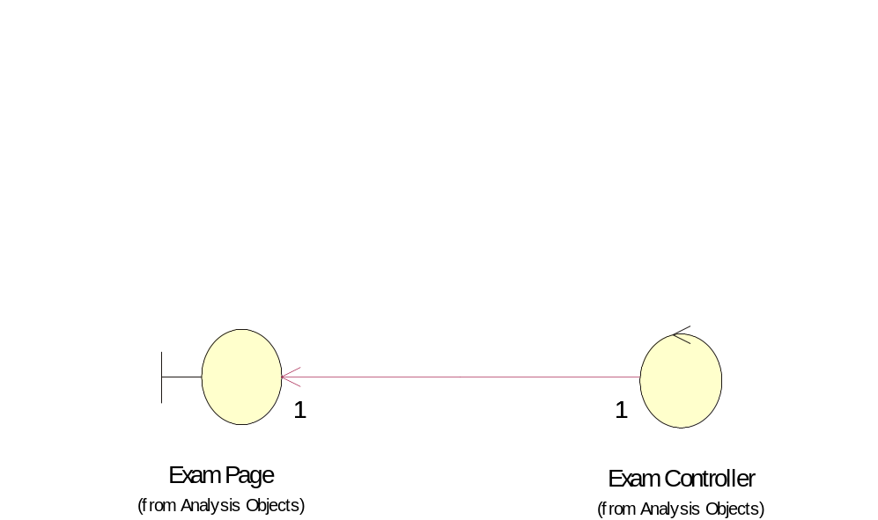

Derived Requirements
No derived requirements.

